Differences between Functional and Non-Functional Testing
Module Name: | Review & Inspection
Test Case ID: | str_id_04
Webpage URL: | https://www.browserstack.com/guide/functional-vs-non-functional-testing

1. Overview
Software testing covers more than just verifying whether features work as expected. It also involves evaluating aspects like performance, security, and usability. This distinction is captured in two broad testing categories: functional and non-functional.
While functional testing ensures feature correctness, non-functional testing guarantees broader standards of reliability and user experience.

2. Functional vs Non-Functional Comparison

2.1 High-Level Comparison
Aspect | Functional Testing | Non-Functional Testing
Objective | Validates what the system does | Evaluates how the system performs
Focus | Business logic and feature correctness | Performance, usability, security, and reliability
Test types | Unit, integration, system, acceptance tests | Load, stress, security, and performance tests
Execution method | Often manual or automated | Mostly automated with specialized tools

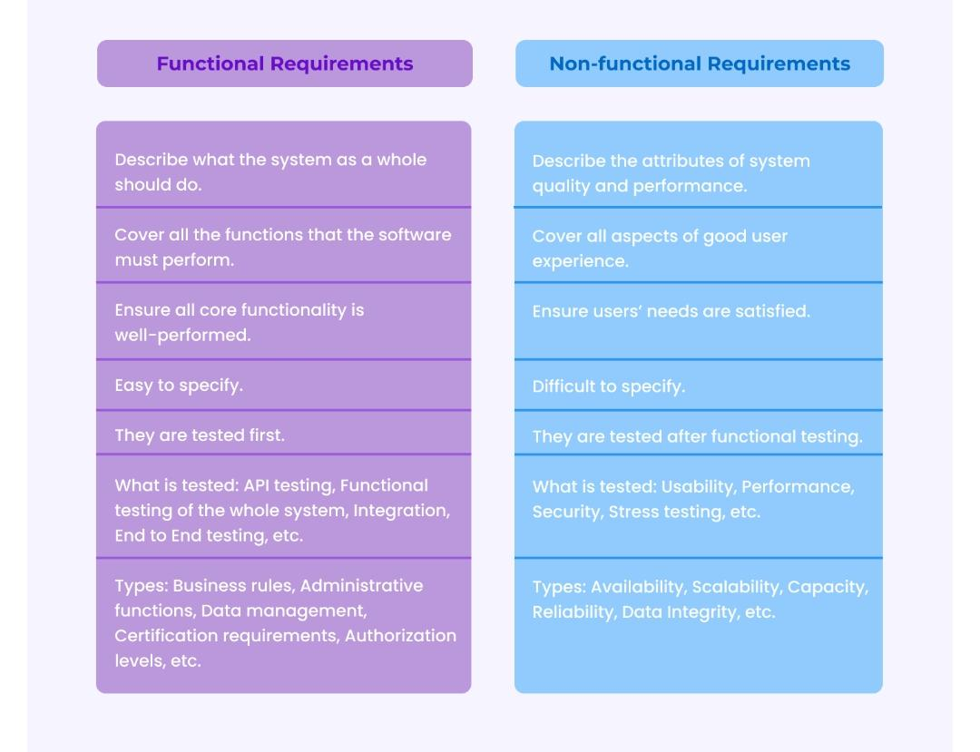

2.2 Detailed Comparison
Aspect | Functional Testing | Non-Functional Testing
Purpose | Verifies whether a website or software performs its intended functions correctly. | Assesses the overall quality and user experience, including performance, security, and scalability.
Focus | Focuses on specific features, interactions, and the correct functionality of the system. | Focuses on performance factors such as speed, stability, scalability, security, and user experience.
Key Examples | Testing form submissions, login functionality, navigation, and content display. | Load testing, stress testing, mobile responsiveness, security testing.
Website Perspective | Verifying link functionality, form interactions, search functionality, and content display. | Testing site performance under heavy traffic, responsiveness on mobile devices, and security measures like SSL certificates.
Application Perspective (BookMyShow App) | Testing features like menu options, data entry, and feature interactions in desktop or mobile software. | Testing the app’s performance under varying load conditions, resource usage, and security during high-demand ticket sales.
Testing Type | Checks that the system functions as per its specifications and requirements. | Assesses the system’s ability to perform effectively under different conditions or meet quality standards.
Performance testing | Not a focus; performance is not tested. | Primary focus; evaluates speed, responsiveness, and load handling.

3. What is Functional Testing?
Functional Testing is a type of software testing that focuses on verifying that a system or application behaves as expected and meets the specified requirements. It ensures that all features and functionalities of the system work correctly from the user's perspective.
Functional testing evaluates whether the system performs its intended functions (user interactions, data processing, feature execution) according to defined specifications.
Key features commonly checked:
- Form submissions: login, contact forms
- Navigation: menus, buttons, and links
- Data input and output: displaying correct search results, processing orders
- Integration with other systems: payment gateways, external APIs
Functional testing is often performed through manual or automated tests that simulate real user conditions. The goal is to ensure that everything works as expected, providing a seamless user experience.

3.1 Types of Functional Testing
- Unit Testing: It is the most granular level of testing in the software development life cycle. It involves developers writing and running tests for individual code units before integrating them into the larger codebase. Each test focuses on a single, isolated component to verify its correctness. Unit testing forms the foundation for more comprehensive testing later in development.
- Component Testing: This testing involves isolating and validating a single software module. It checks for bugs within a component and verifies that multiple units within that component work together as intended. Component testing requires more complex scripts and deeper test coverage at the module level than unit tests.
- Integration Testing: Once individual components are validated, integration testing checks how they function together. This type of testing is essential, especially when different team members develop different modules. In systems built with microservices, integration testing ensures that the interactions between services work smoothly and without conflict.
- System Testing: It evaluates the software as a whole, fully integrated system to ensure it meets all technical and business requirements. Also referred to as end-to-end (E2E) testing, it requires a test environment that closely mirrors real user conditions. This stage verifies that the software is ready for customer use.
- Regression Testing: This testing is performed after changes are made to the codebase, such as bug fixes or feature enhancements. The goal is to ensure that existing functionality remains unaffected and the application’s overall stability is preserved. It helps maintain the integrity of the software throughout continuous development.
- Sanity Testing: It focuses on verifying the correctness of recent software changes. It is typically conducted after receiving a new build, concentrating only on the modified or fixed areas. Sanity testing ensures the core functionality remains intact before the application proceeds to deeper testing stages.
- Smoke Testing: It is conducted once a build is completed to confirm that critical functions of the application are working. Often considered a preliminary check, it acts as a gatekeeper before more extensive testing begins, such as user acceptance testing or a production release. It helps identify major issues early in the QA cycle.

4. What is Non-Functional Testing?
Non-Functional Testing refers to testing the non-functional aspects of a system, focusing on how well the system performs rather than whether it functions correctly. This type of testing evaluates the overall quality attributes of the system, such as performance, security, usability, scalability, and reliability, to ensure that the system can handle real-world usage scenarios under varying conditions.
Unlike Functional Testing, which verifies that specific features or functions work as expected, non-functional testing assesses whether the system meets key standards and user expectations for performance, speed, and overall user experience.

4.1 Types of Non-Functional Testing
- Performance Testing: It evaluates how efficiently a software application performs under expected conditions. Performance testing focuses on key metrics such as loading speed, crash frequency, memory usage, response time, and CPU consumption. This type of testing ensures the application runs smoothly and meets performance expectations.
- Security Testing: This testing examines the software for vulnerabilities that malicious actors could exploit. It involves scanning the system for weak points in authentication, data handling, and access control to ensure data protection and application integrity.
- Visual Testing: It checks the accuracy of UI elements, including layout, font, color, and positioning. It ensures that the application’s appearance is consistent across devices and browsers, and that the user interface matches the design specifications.
- Stress Testing: This testing pushes the system beyond normal operating limits to assess its behavior under extreme conditions. It helps identify the application’s breaking point and ability to recover from crashes or failures.
- Scalability Testing: This type of testing evaluates how well the application can grow to accommodate more users, data, or transactions. It ensures that performance remains consistent even as demand increases, making it essential for long-term system planning.
- Responsive Testing: It ensures that the application displays and functions properly across different screen sizes and devices. This includes testing mobile phones, tablets, and desktops to guarantee a seamless user experience regardless of the device used.
- Load Testing: It includes measuring how a system handles increased user activity or demand, such as multiple logins or simultaneous transactions. This type of testing helps identify performance bottlenecks and ensures the application remains stable and responsive under typical and peak usage scenarios.

5. Example of a Functional Test (BookMyShow App Context)
The following examples show how different types of functional tests are applied in a real-world scenario (e.g., ticket booking or in-app feature workflow):
- Unit Test: Consider a ticket-booking app introducing a snack pre-ordering feature. One of the new functions is an 'Add to Cart' button. A unit test would be run to verify that this button works as expected in isolation.
- Module Test: The app wants to show users nearby event centers or theaters based on their GPS data. Verifying this function requires a module test, as it requires multiple units to work together to get the expected result.
- Integration Test: The app offers users the ability to directly transfer money from their bank account to the app’s own 'wallet' for faster purchases. At this point, two modules come into play and tests must be run to check how well they integrate to get the job done.

6. Conclusion
Both functional and non-functional testing are essential components of a comprehensive quality assurance strategy. Functional testing ensures the software does what it is supposed to do. Non-functional testing ensures it does so efficiently, securely, and reliably under real-world conditions. Organizations that invest in both deliver higher-quality products, reduce post-release defects, and provide superior user experiences.

